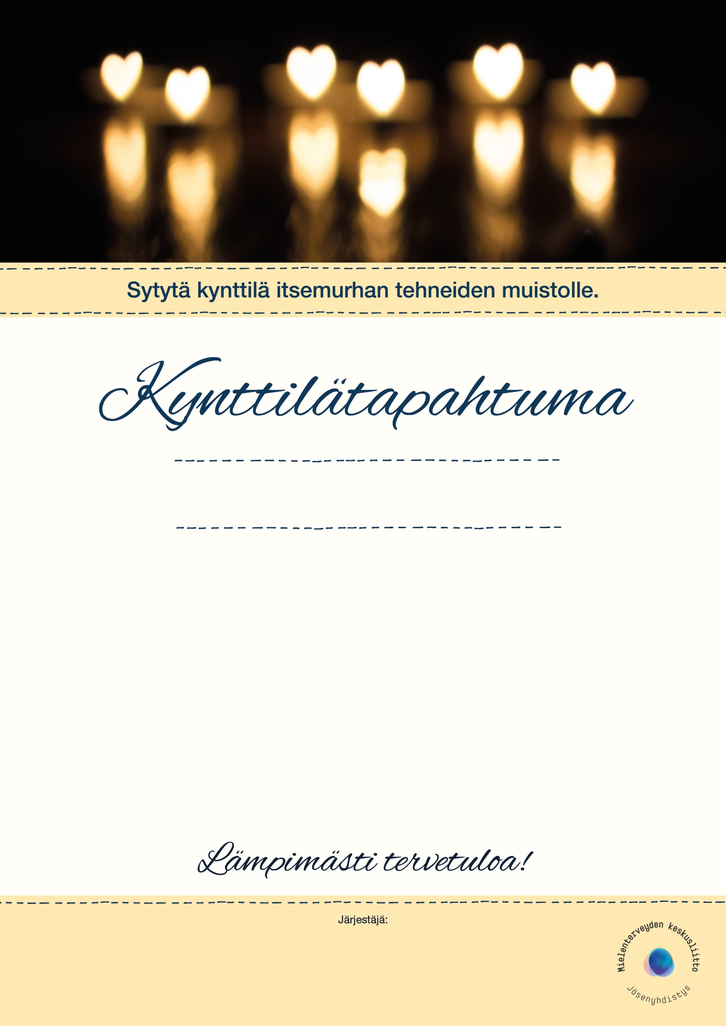

xx:xx Lorem ipsum dolor sit, consectetuer adipiscing elit.

xx:xx Lorem ipsum dolor sit, consectetuer adipiscing elit.

xx:xx Lorem ipsum dolor sit, consectetuer adipiscing elit.

xx:xx Lorem ipsum dolor sit, consectetuer adipiscing elit.

xx:xx Lorem ipsum dolor sit, consectetuer adipiscing elit.

xx:xx Lorem ipsum dolor sit, consectetuer adipiscing elit.

xx:xx Lorem ipsum dolor sit, consectetuer adipiscing elit.

**17.11.2019 klo xx**

Paikka |osoite

**OHJELMA**

Yhdistyksen nimi tähän