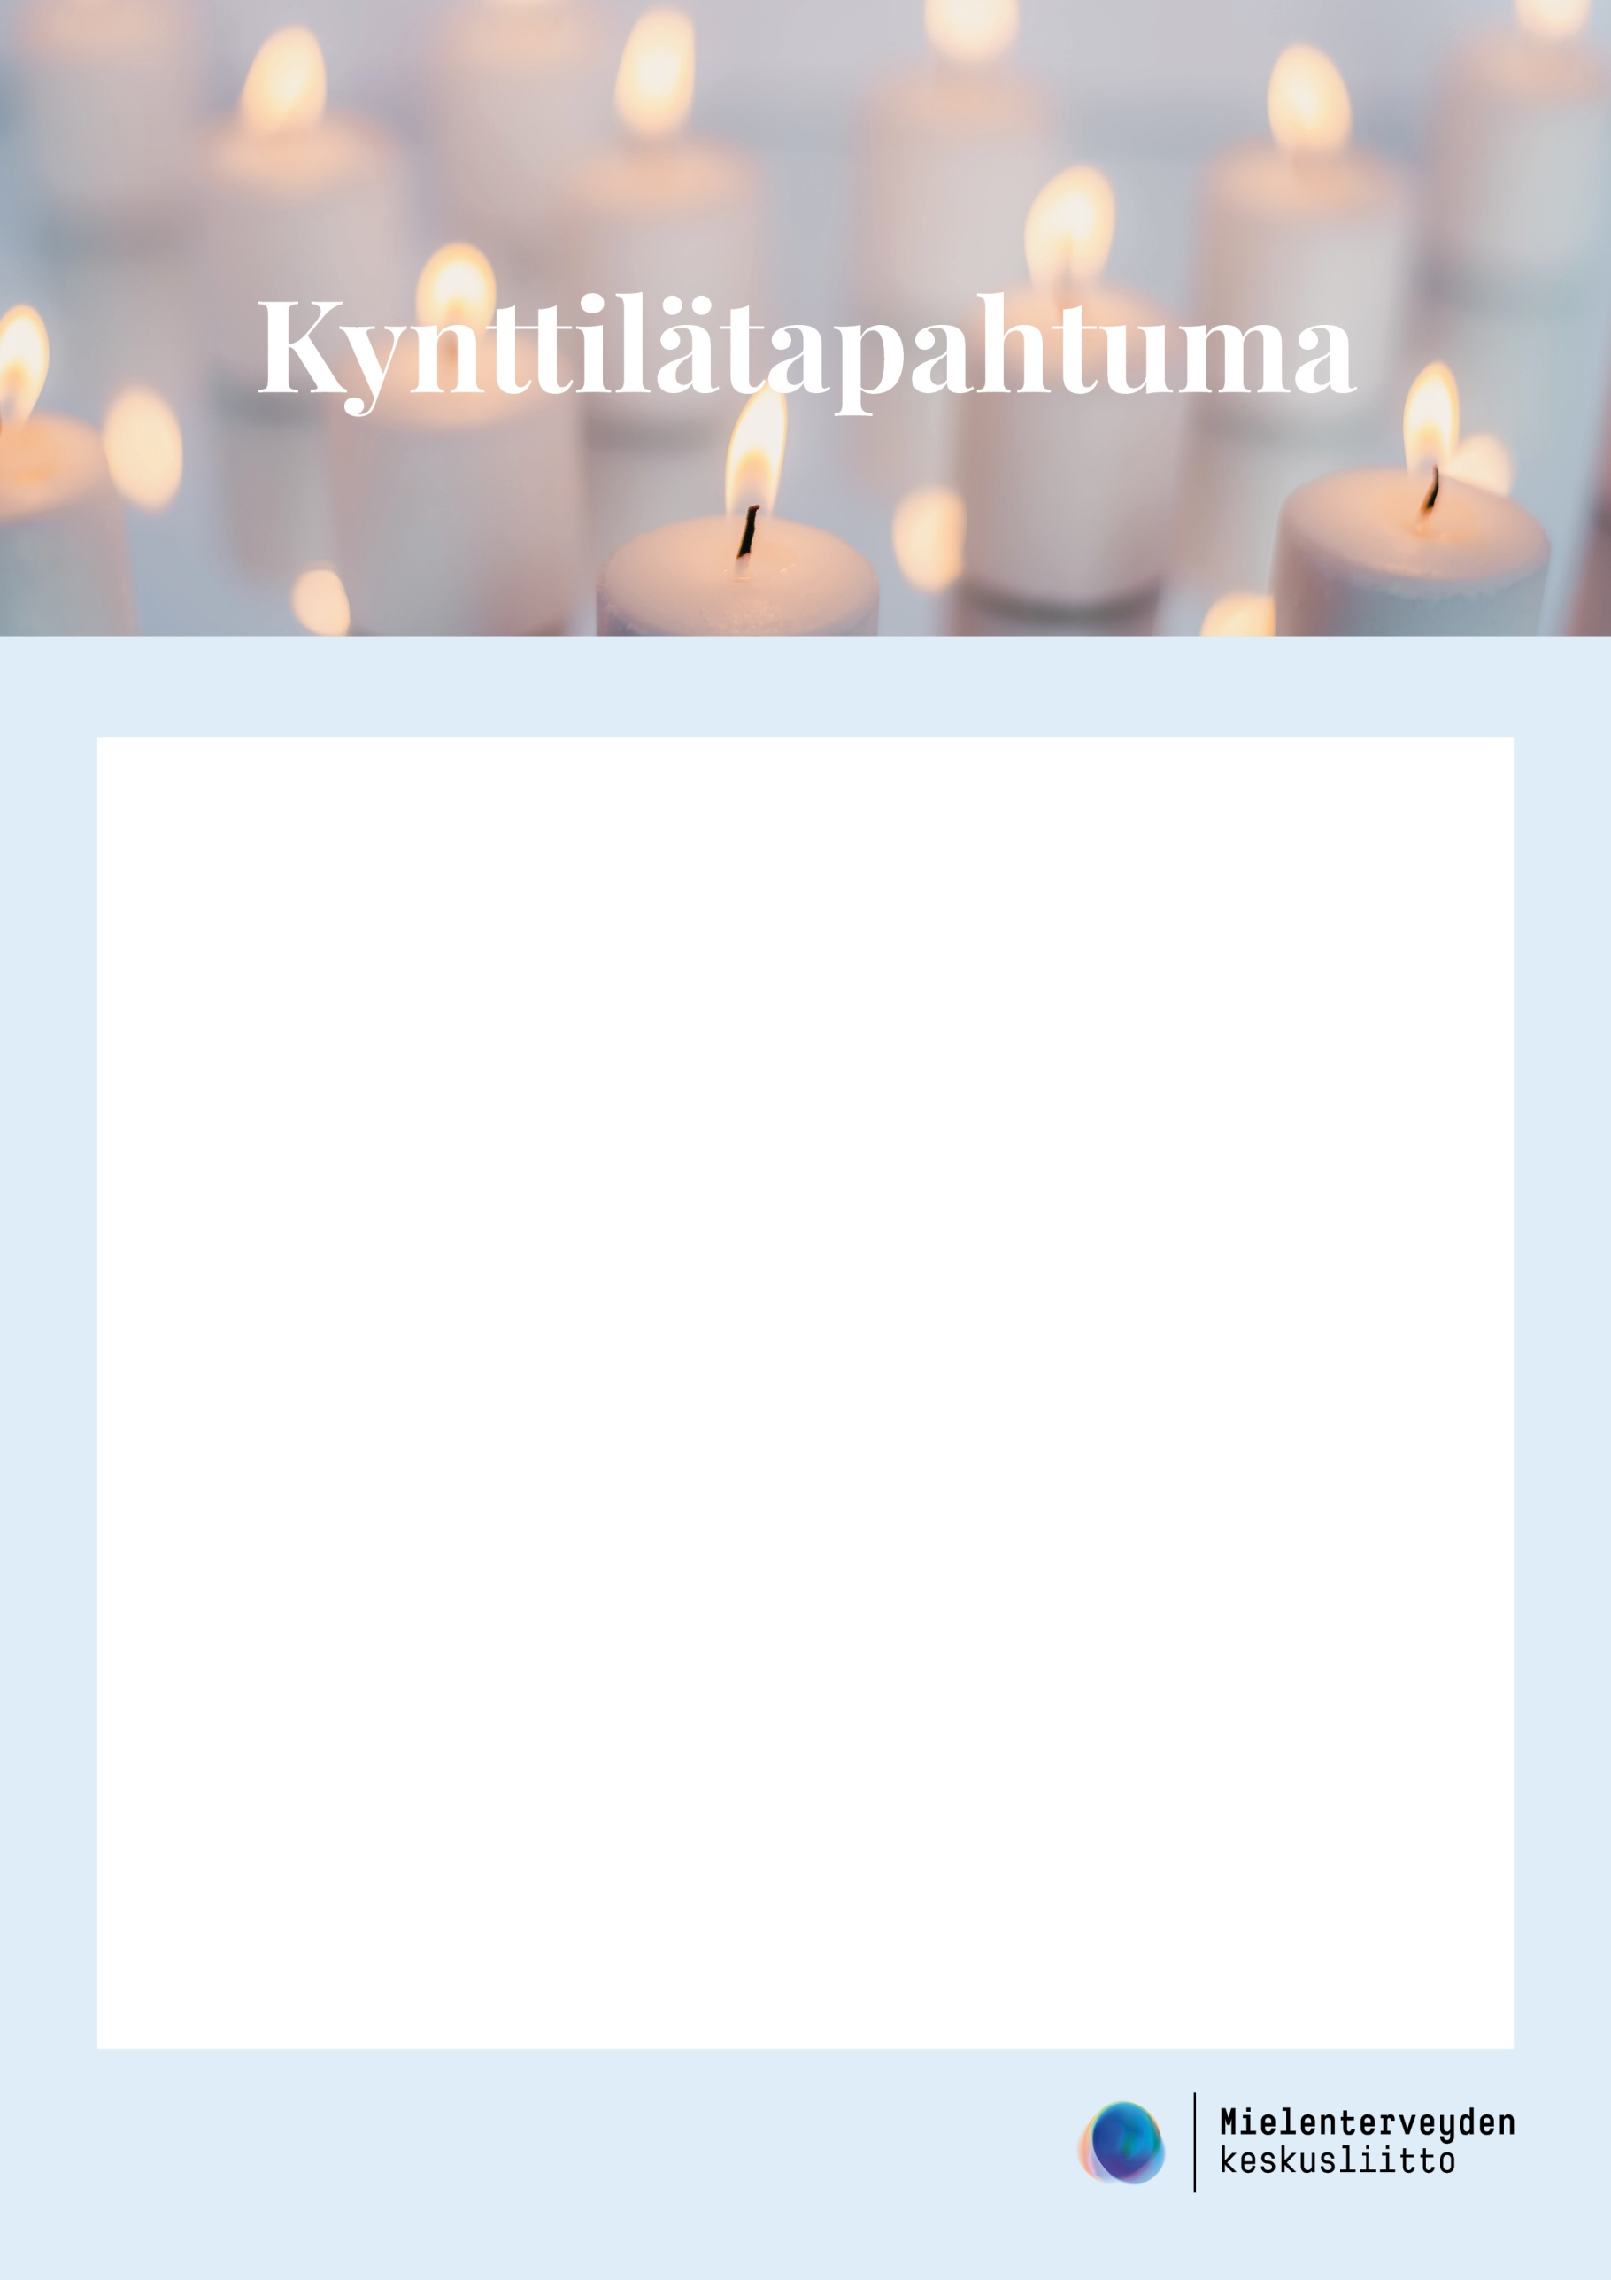

xx:xx Lorem ipsum dolor sit, consectetuer adipiscing elit.

xx:xx Lorem ipsum dolor sit, consectetuer adipiscing elit.

xx:xx Lorem ipsum dolor sit, consectetuer adipiscing elit.

xx:xx Lorem ipsum dolor sit, consectetuer adipiscing elit.

xx:xx Lorem ipsum dolor sit, consectetuer adipiscing elit.

xx:xx Lorem ipsum dolor sit, consectetuer adipiscing elit.

xx:xx Lorem ipsum dolor sit, consectetuer adipiscing elit.

**15.11.2020 klo xx**

paikka

**OHJELMA**